**MEMORY  
AND  
FILE HANDLING**

SARTHAK SANAY

**(1) AIM:-**

To explore the concept of dynamic memory allocation using malloc() and free().

**CODE:-**

**// Program in C to allocate dynamic memory using malloc() and then free the memory using free()**

**#include <stdio.h>**

**#include <stdlib.h>**

**int main()**

**{**

**int n;**

**printf("Enter number of elements: ");**

**scanf("%d", &n);**

**// Dynamically allocate memory using malloc()**

**int *ptr = (int*)malloc(n * sizeof(int));**

**if(ptr != NULL)**

**printf("Memory allocated dynamically using malloc()\n");**

**// Storing the elements of the array**

**for(int i=0; i<n; i++)**

**{**

**ptr[i] = i+1;**

**}**

**// Printing the elements of the array**

**for(int i=0; i<n; i++)**

**{**

**printf("%d\t", ptr[i]);**

**}**

**// Deallocating the memory**

**free(ptr);**

**printf("Memory deallocated succesfully using free()");**

**return 0;**

**}**

**OUTPUT SCREEN:-**

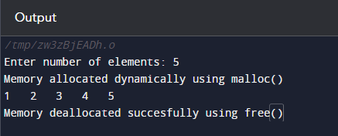

**(2) AIM:-**

To write programs in C to read from and write to files.

**CODE 1:- (Read from files)**

**// Program in C to read files**

**#include <stdio.h>**

**#include <stdlib.h>**

**int main()**

**{**

**FILE* ptr;**

**char str[50];**

**ptr = fopen("test.txt", "a+");**

**if(ptr == NULL)**

**{**

**printf("Error occured while opening file!\n");**

**exit(1);**

**}**

**printf("Contents of the file are as follows:-\n");**

**while(fgets(str, 50, ptr) != NULL)**

**{**

**printf("%s", str);**

**}**

**fclose(ptr);**

**return 0;**

**}**

**INPUT FILE:-**

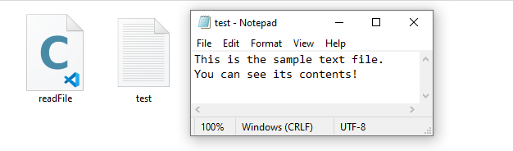

**OUTPUT SCREEN:-**

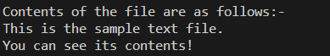

**CODE 2:- (Write to files)**

**// Program in C to write files**

**#include <stdio.h>**

**#include <stdlib.h>**

**int main()**

**{**

**FILE* ptr;**

**ptr = fopen("./hello.txt", "w+"); // opens file**

**if(ptr == NULL)**

**{**

**printf("Error occured while writing to file!");**

**exit(1);**

**}**

**char str[] = "This is all the data to be inserted into the file.";**

**fputs(str, ptr); // puts data inside the file**

**fclose(ptr); // file closed**

**printf("Data written inside the file successfully!");**

**return 0;**

**}**

**BEFORE RUNNING PROGRAM:-**

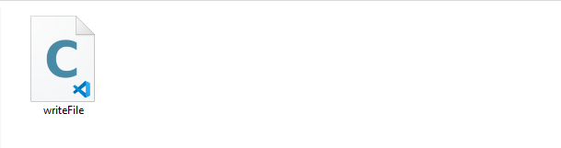

**AFTER RUNNING PROGRAM:-**

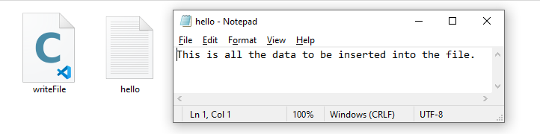

**OUTPUT SCREEN:-**

